Event: Expert Talk

Subject:

1) Sensor Linearization using multi linear model techniques (1.00 to 3.00 pm)

Resource Person: Dr. Prashant Sarwade

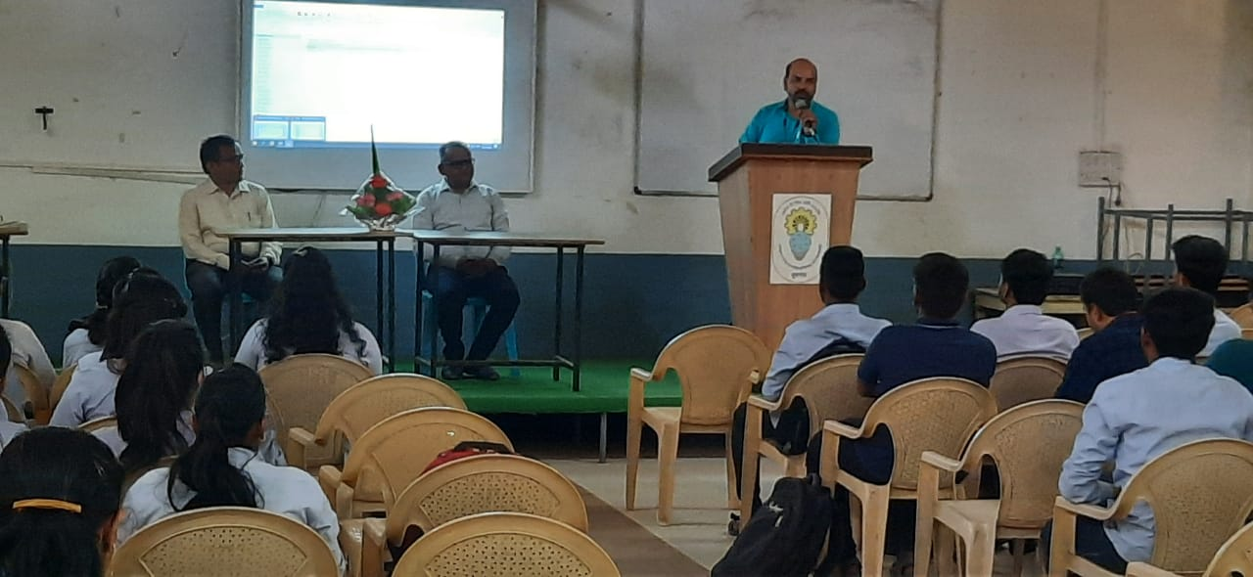

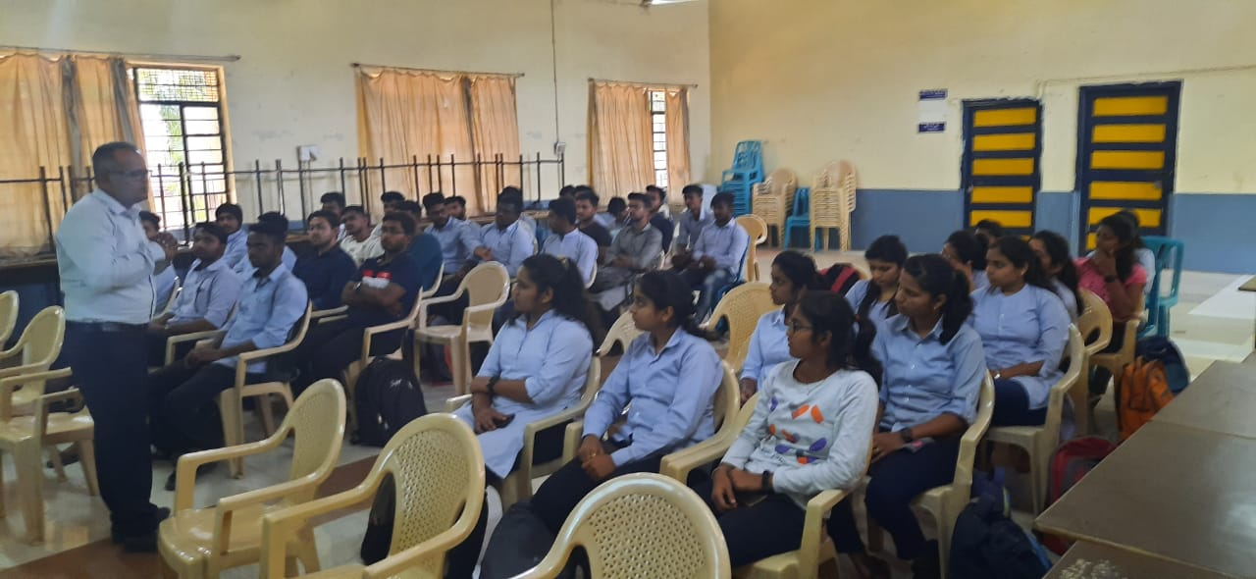

***Activity***

Event: Workshop 18.5.23 – 20.5.23

Subject: Workshop on “Industrial Automation”

Resource Person: Mr Abhishek Phadke Ganlakxmi Industries Sangli

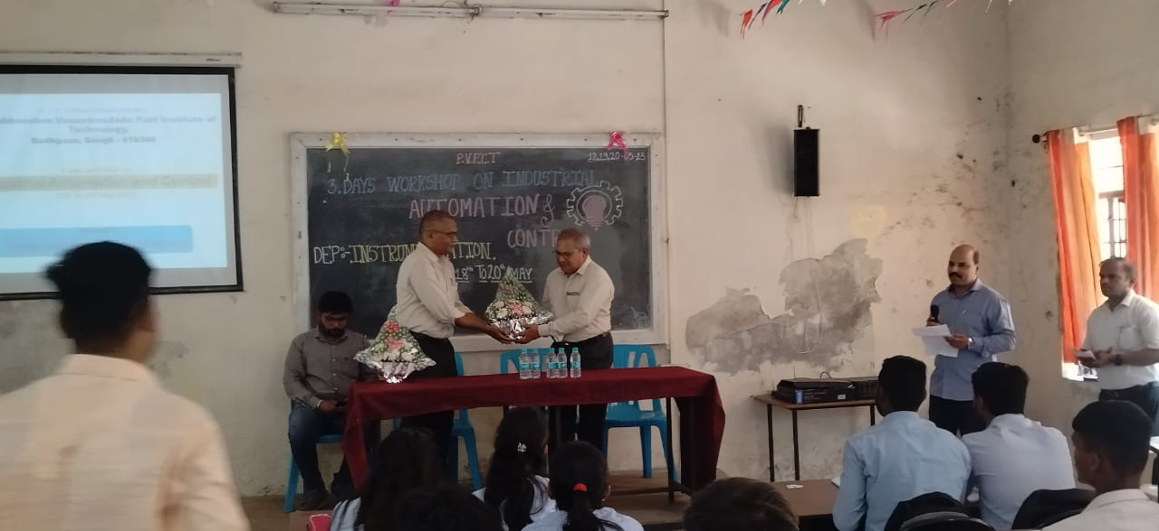

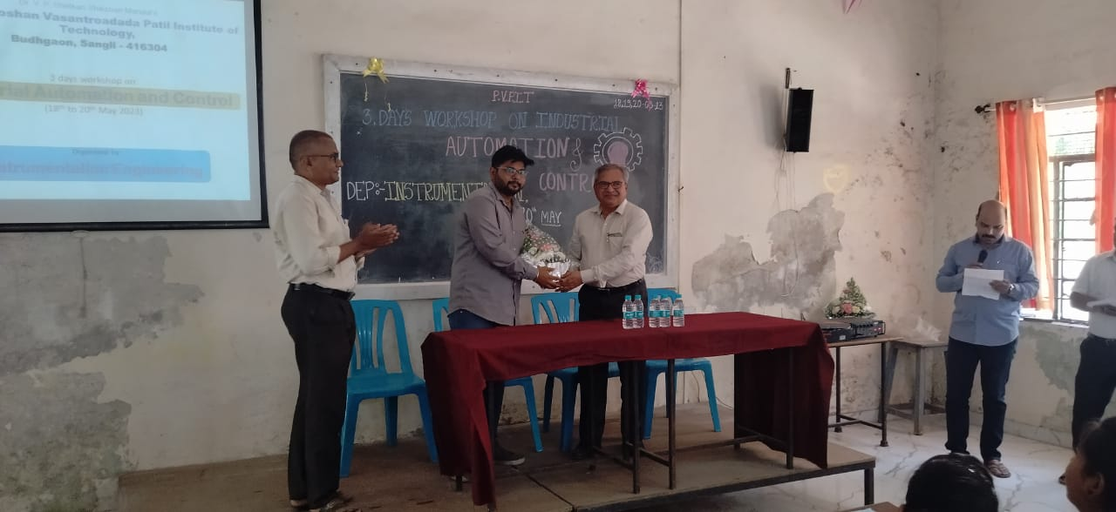

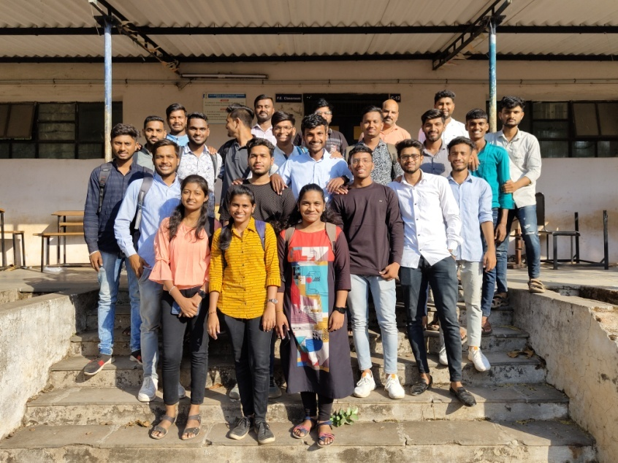

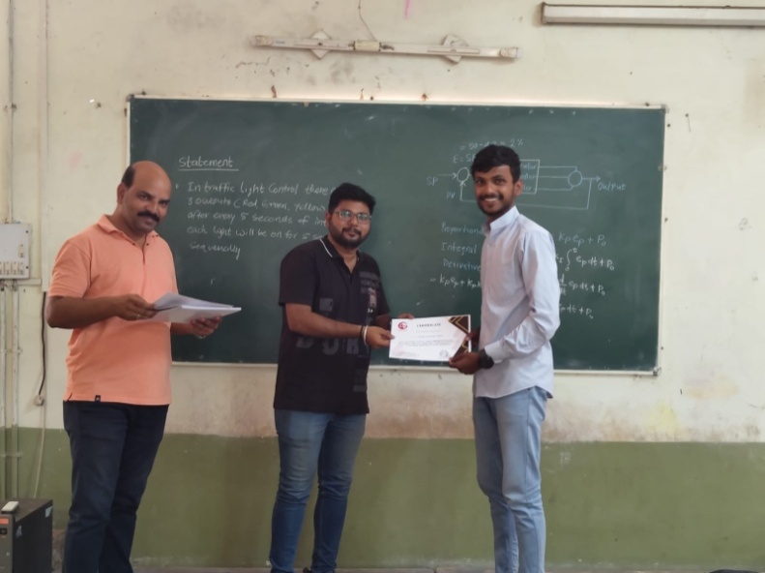

**Expert Lecture Alumni By Mr Kunal Lohar Dt: 23.5.23**

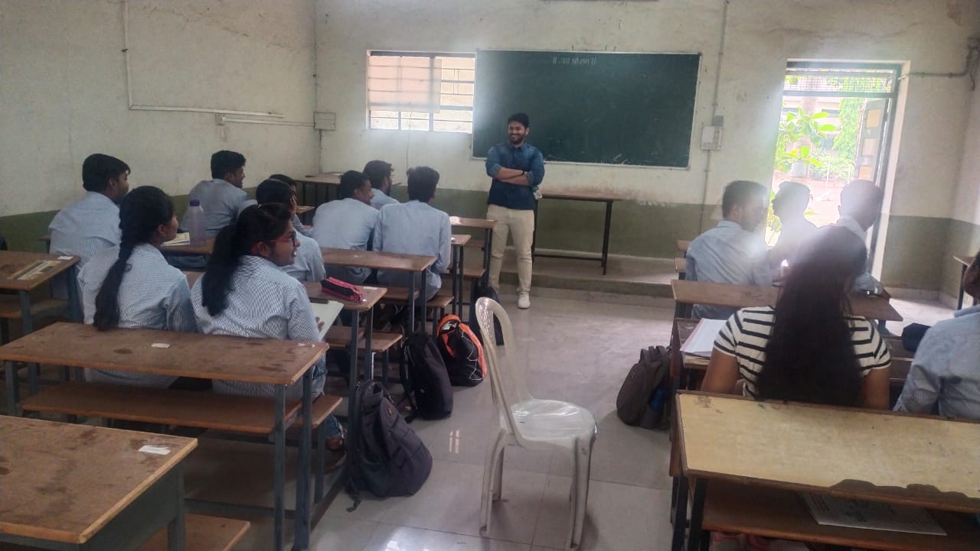

**Photographs of Hospital Visit**

**Date: 09/12/22**

**Kolhapur Cancer Hospital, Kolhapur**

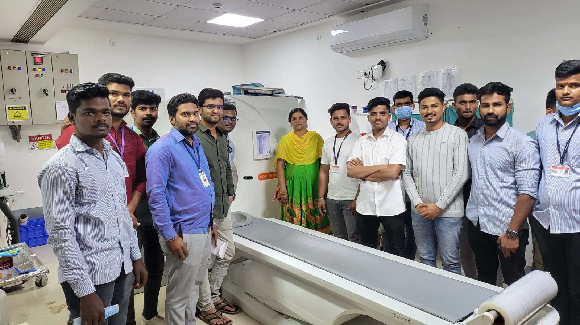

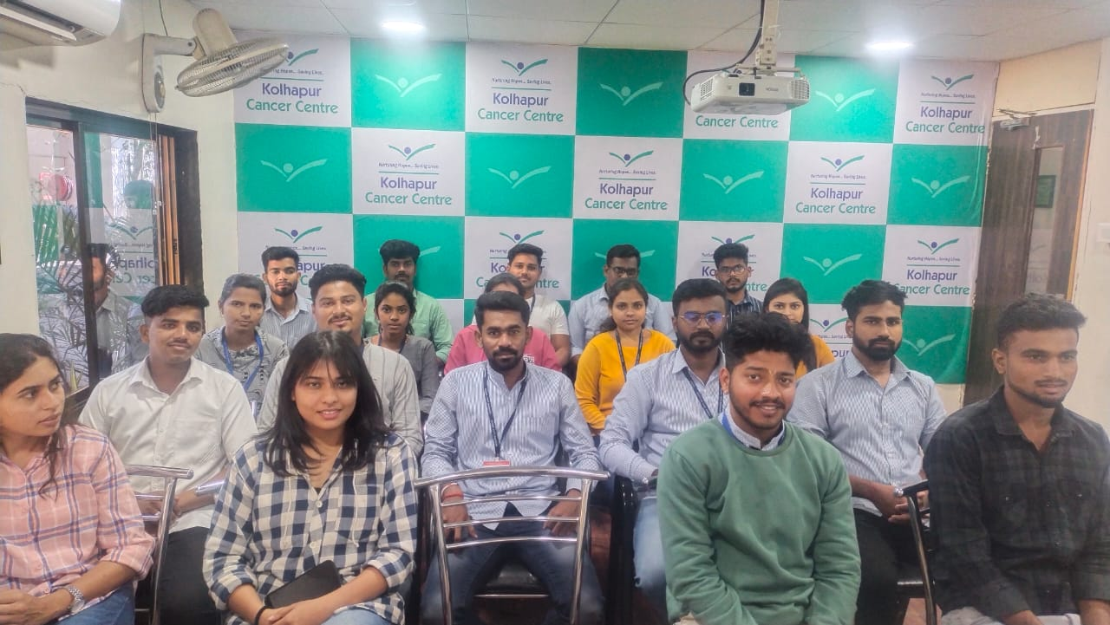

**Expert Lecture** on Futuristic opportunities in E vehicle

Eminent speaker - Anand Thakar

